Virtual CLASSROOM / SkillSwap App (Peer-to-Peer Learning Platform)
SkillSwap Project Report: A Global Peer-to-Peer Learning Platform
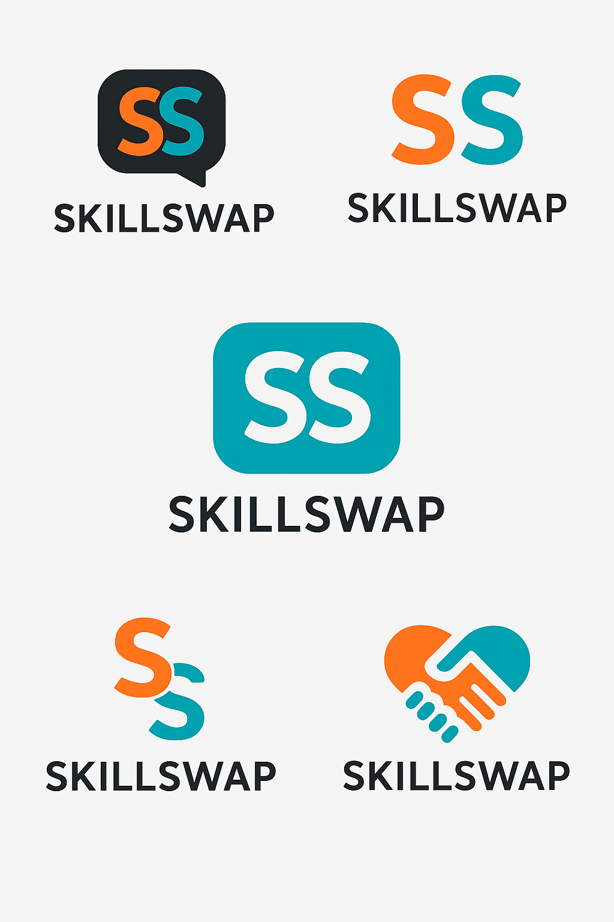

Overview
SkillSwap is a peer-to-peer learning platform that enables users to exchange skills directly. For instance, a person can teach guitar lessons in exchange for Excel tutorials. This approach eliminates financial barriers, builds communities, and promotes continuous learning.

Problem Solved
High costs of professional courses and limited access to affordable learning opportunities.

Revenue Model
The app generates revenue through ad-free premium memberships, offering advanced matching, exclusive mentor access, and an enhanced user experience.

Prototype
Web or mobile prototype using Firebase.

10 Major Benefits
- 1. Affordable Learning – Exchange knowledge instead of money.
- 2. Community Building – Build a friendly learning and teaching community.
- 3. Personalized Skill Growth – Find mentors and learners with shared goals.
- 4. Global Accessibility – Join from anywhere in the world.
- 5. Boosts Soft Skills – Enhance communication and leadership by teaching others.
- 6. Portfolio Creation – Showcase your expertise and learning journey.
- 7. Encourages Lifelong Learning – Promotes continuous personal development.
- 8. Equal Opportunity Platform – Open for everyone regardless of background.
- 9. Time Efficiency – Learn faster with flexible sessions.
- 10. Networking & Collaboration – Connect for projects and career growth.

10 Key Features / Functions
- 1. User Profiles – List teachable and learnable skills.
- 2. Skill Matching System – AI matches users for complementary skills.
- 3. Chat & Video Call System – Enables real-time lessons.
- 4. Rating & Review System – Builds trust through user feedback.
- 5. Scheduling & Calendar – Manage lesson times easily.
- 6. Skill Verification – Earn badges or certificates for verified teaching.
- 7. In-App Notifications – Stay updated on matches and sessions.
- 8. Learning Progress Tracker – Track milestones and learning history.
- 9. Community Forums – Exchange ideas and resources.
- 10. Premium Membership – Ad-free, advanced matching, and expert access.

10 Unique Elements That Make SkillSwap Stand Out
- 1. Barter-Based Learning Concept – No monetary exchange required.
- 2. Gamification – Reward points and badges for active participation.
- 3. Smart AI Matching – Connects users based on skills and availability.
- 4. Diversity in Skills – Academic and creative areas supported.
- 5. Offline + Online Mode – Offers local meetups and virtual options.
- 6. Safety Features – Verified profiles and secure communication.
- 7. Analytics Dashboard – Insights on user engagement and trends.
- 8. Localization – Multilingual support for global users.
- 9. Mentorship Mode – Paid or free mentoring options.
- 10. Integration with LinkedIn – Export verified skills directly.

Development Plan
1. Prototype Design – Create wireframes using Figma or Canva.
2. Backend Development – Use Firebase for data storage and real-time updates.
3. Frontend Development – Build the mobile app using Flutter or React Native.
4. Team Roles – Assign developer, designer, and business planner roles.
5. Presentation – Highlight problem, target market, business model, and demo flow.
New Major Feature: Global Communication System
Purpose:
To eliminate communication barriers among users worldwide and enable smooth, real-time global collaboration.
Description:
The Global Communication feature will allow users to connect and interact across borders with built-in real-time translation, multi-language chat, and voice/video call translation tools.
This promotes cultural exchange, enhances understanding, and allows learners and teachers from different regions to collaborate without the limitation of language.
Sub-Features:
- Instant Language Translation: Messages translated automatically into the user’s preferred language.
- Voice & Video Translation: Real-time subtitle or audio translation during lessons.
- Cultural Mode: Adds cultural context to translated phrases for better understanding.
- Global Time Synchronization: Smart scheduling based on time zones for international sessions.
- Language-Based Matchmaking: Helps connect users with complementary language preferences (e.g., English ↔ Spanish).
- International Community Boards: Global discussion threads filtered by language and skill category.
- Virtual “Global Classroom”: Live international workshops for skill sharing and discussions.
- Accent Neutralization Mode: Optional voice feature that converts accents for easier comprehension.
- AI Moderation: Prevents miscommunication or inappropriate content across languages.
- Cross-Cultural Learning Analytics: Tracks global engagement and participation metrics.

2 Abstract (½–1 page)
Skill Swap is a virtual classroom and peer-to-peer learning platform where users exchange skills directly instead of paying money. This system allows a learner to become a teacher and a teacher to become a learner, depending on the skills they offer and need. The core model is barter-based learning, eliminating financial barriers.
The project addresses the challenge of expensive professional courses and limited access to quality learning opportunities, especially for students and self-learners. By using a barter-based model, AI-driven matching, and rich communication tools, SkillSwap promotes affordable, community-driven, and globally accessible learning. The planned Global Communication System is a major innovation, offering real-time translation to connect users worldwide. This positions SkillSwap as a unique, high-potential venture in the education technology sector.

Introduction (1–2 pages)
3.1 Background
Education and skill development are essential for academic success and employability. However, formal courses and premium online platforms are often costly and inaccessible for many learners. Simultaneously, millions possess valuable, underutilized skills. Digital platforms now allow knowledge to be shared quickly and at scale. A system that enables people to trade skills instead of money can democratize learning and transform personal and professional growth. SkillSwap is designed to fill this gap.
This project relates directly to the Economic Impact of Entrepreneurial Firms, as SkillSwap aims to be a Type of Start-Up Firm that introduces an entirely new model (Innovation) into the educational market, challenging the status quo of paid learning platforms.
3.2 What is SkillSwap?
SkillSwap is a virtual classroom / peer-to-peer learning app where users create profiles, list teachable and learnable skills , and are matched by the platform for an exchange of lessons. The exchange could be "Guitar for Excel," "Graphic Design for English Speaking," or "Programming for Marketing Basics".
The app integrates key features like a Skill Matching System , Chat & Video Call System , Scheduling & Calendar , and a Rating & Review System. Its primary distinguishing feature is the Barter-Based Learning Concept coupled with the Global Communication System , which features real-time translation to connect learners and teachers across borders.

4. Problem Statement (1–1.5 pages)
Many learners face three core problems:
- High fees for quality courses and coaching.
- Limited access to mentors, especially in small cities or low-income communities.
- Language and cultural barriers when learning from people in other countries.
Traditional platforms focus on one-way, paid models, treating learners mainly as customers. SkillSwap proposes a two-way, barter-based system where both sides share and gain value. The use of technology, specifically the Global Communication System , removes language and time-zone barriers. This approach addresses the problem of High costs of professional courses and limited access to affordable learning opportunities.
This project identifies an Opportunity by solving a market pain point (high cost) and leveraging technology to overcome a significant barrier (language), making it a high-potential venture whose window of opportunity is open due to the rise of remote work and global connectivity.

5. Objectives of the Project (1 page)
5.1 Primary Objectives
- Provide an affordable learning platform through skill exchange instead of money.
- Build a global community where anyone can become both a learner and a teacher.
- Implement a Global Communication System with live translation to connect users worldwide.
5.2 Secondary Objectives
- Enhance users’ soft skills such as communication, leadership, and presentation by teaching others.
- Encourage lifelong learning and continuous personal development.
- Offer tools like progress tracking, badges, and portfolios to showcase learning journeys.

6. Scope of the Project (1–1.5 pages)
The initial scope focuses on building a working prototype of SkillSwap as a mobile or web application using Firebase. The prototype will support:
- User registration and User Profiles.
- Skill listing and basic AI-based matching.
- One-to-one chatting and session scheduling.
The project also explores advanced features like in-app video calling, a Rating & Review System , Gamification , and the groundbreaking Global Communication System. While the early version can be implemented with a limited budget , the long-term vision includes scaling the platform to thousands of users and integrating professional mentorship and certifications. This follows the Corridor Principle (CP), where a new venture opens up unforeseen opportunities and paths for future growth.

7. System Overview (1–2 pages)
7.1 Core Concept
SkillSwap is built around the concept of barter-based learning. Users pay with time and knowledge rather than money. This approach lowers financial barriers, motivates users to share expertise, and forms a network where every learner is also a contributor.
7.2 Major Benefits
- Affordable Learning – Users exchange knowledge instead of paying tuition fees, making quality learning possible even for those with limited budgets.
- Community Building – The platform forms a friendly community of learners and teachers who support each other, not just consume content.
- Personalized Skill Growth – Matching connects people with similar goals, so learning paths feel more relevant and customized.
- Global Accessibility – Anyone with an internet connection can join, regardless of city or country, offering truly global education.
- Boosts Soft Skills – Teaching others improves communication, confidence, and leadership.
- Portfolio Creation – Users can document classes taught, reviews received, and milestones achieved to build a learning portfolio.
- Lifelong Learning – The app encourages users to learn continuously, promoting continuous personal development.
- Equal Opportunity Platform – The system is open to people from all backgrounds, not only those who can pay.
- Time Efficiency – Flexible online sessions save travel time and allow learning
- at convenient hours. Networking & Collaboration – Users can discover partners for projects, startups, or career opportunities.
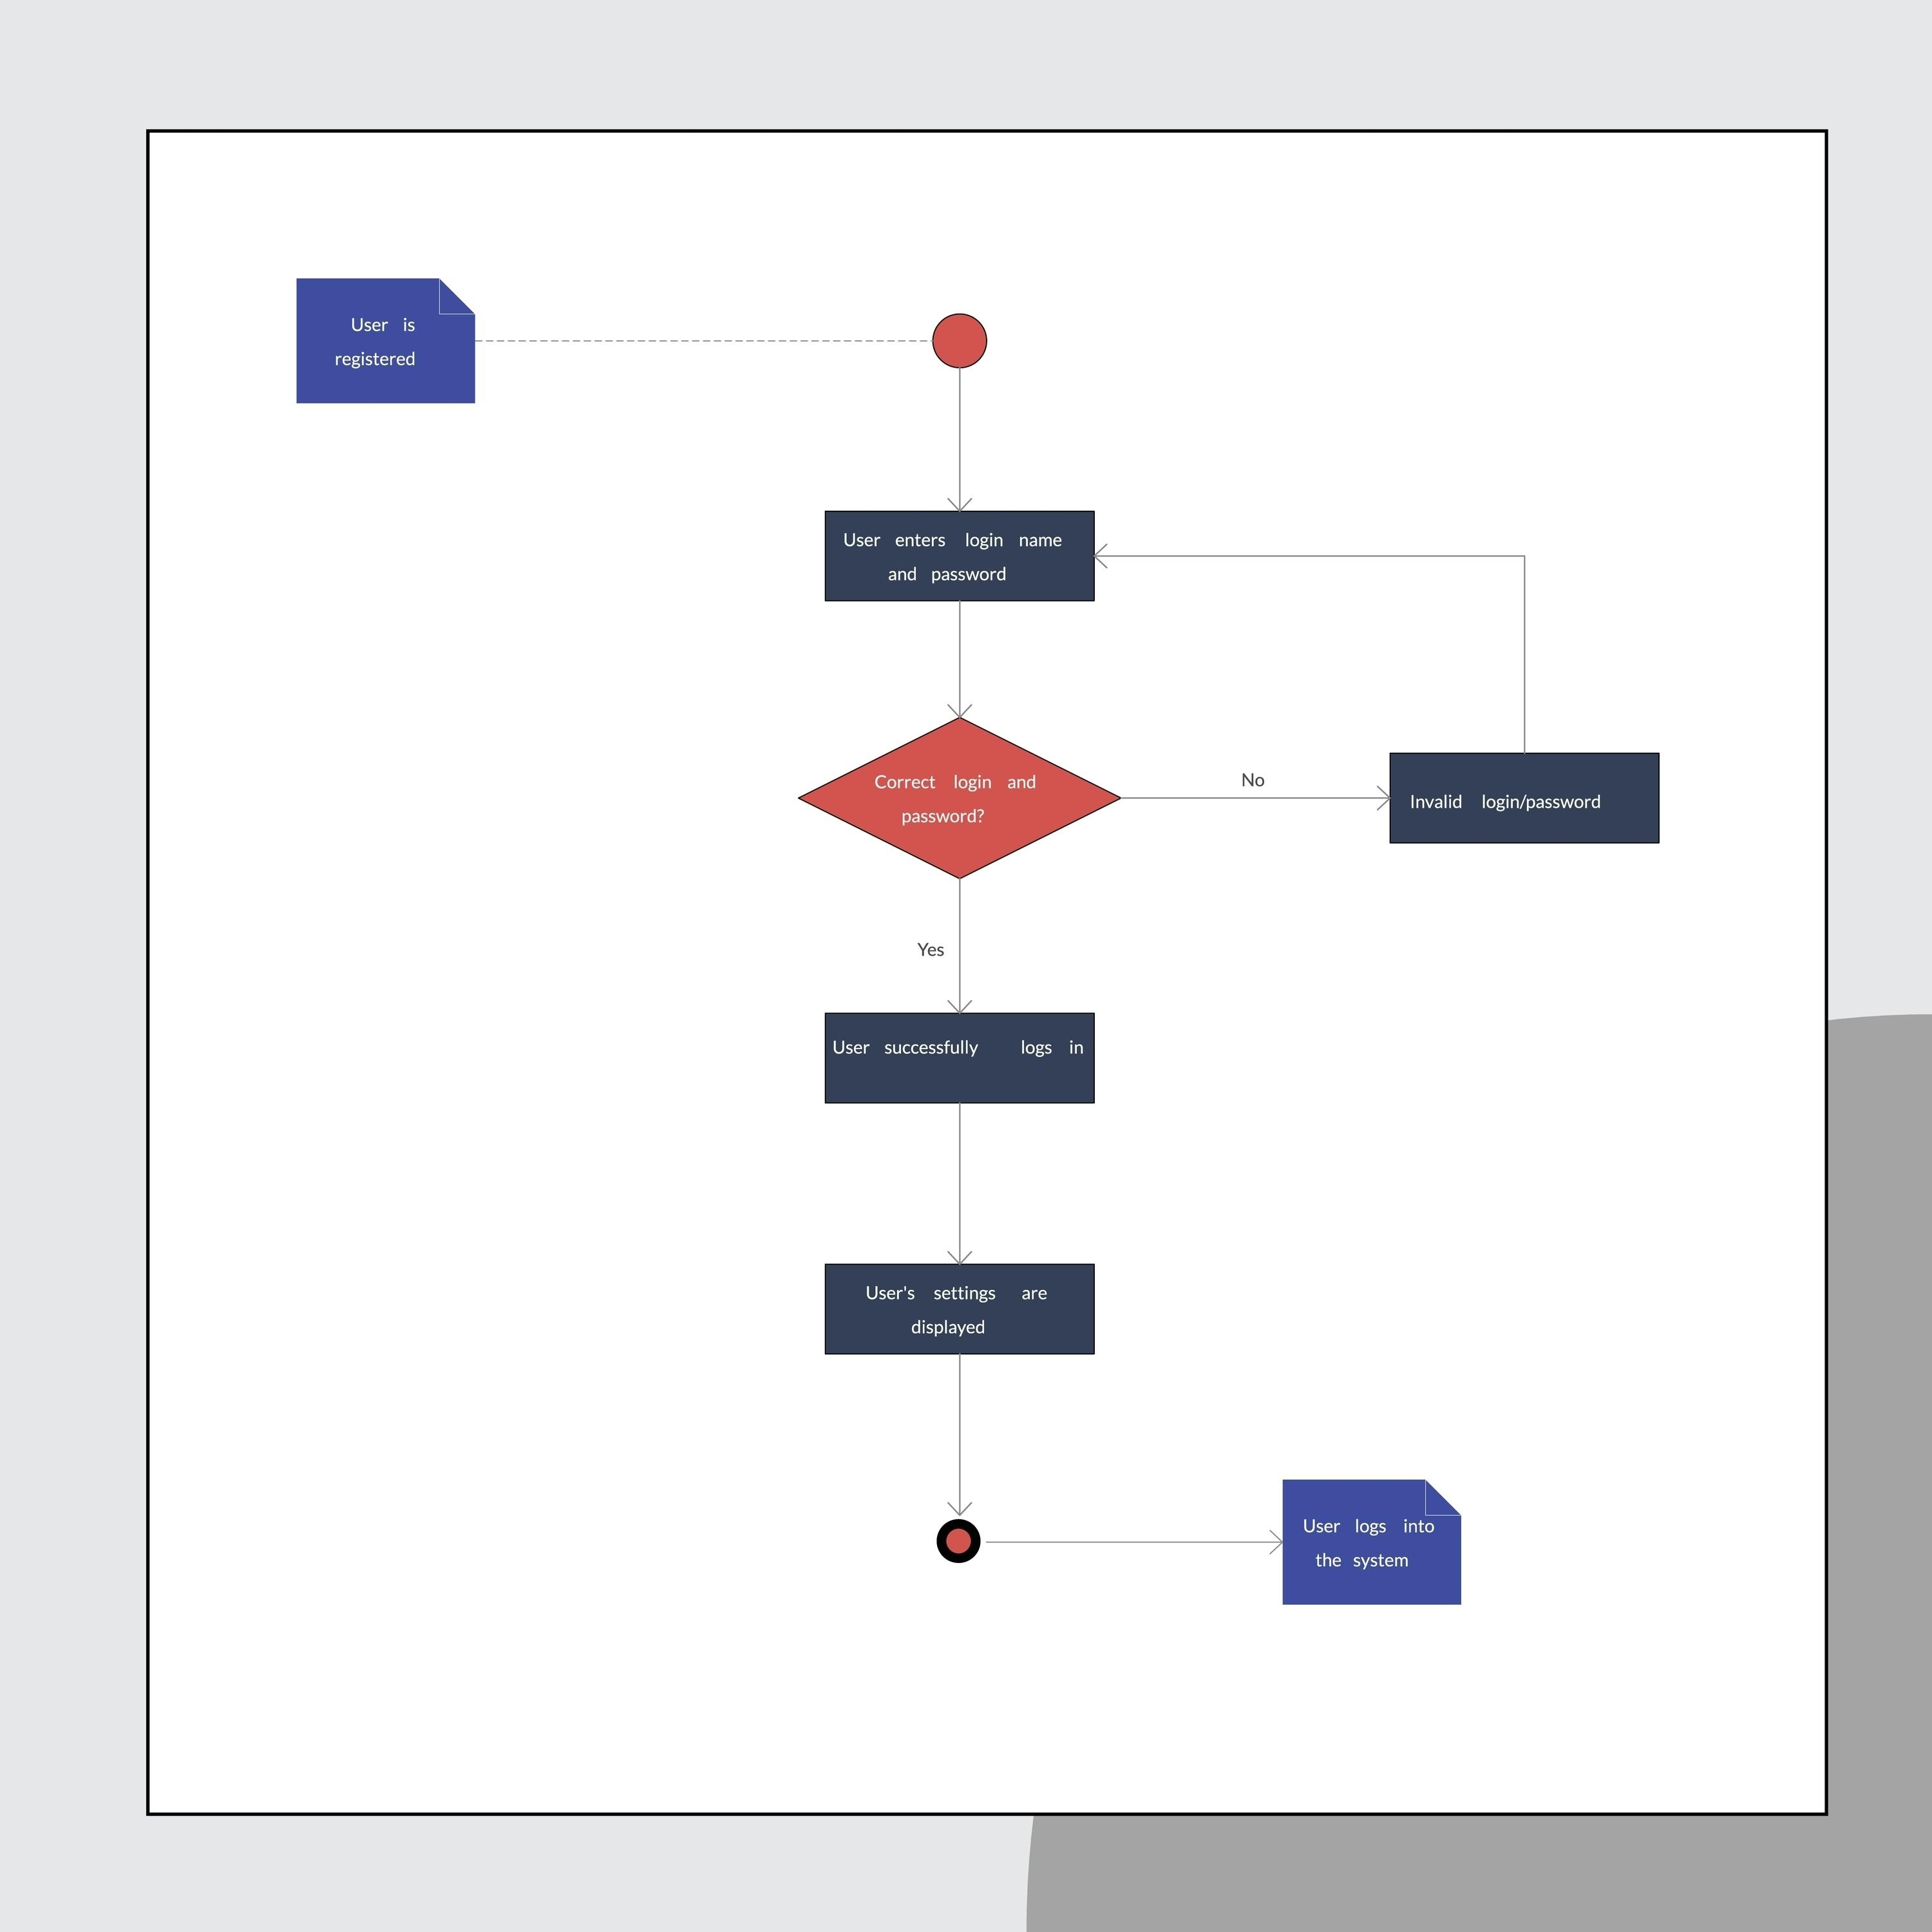

8. Key Features and Modules (2–3 pages)
- User Profiles – Each user has a profile showing bio, teachable skills, learning interests, ratings, and badges. This module is essential for the platform's core matching function.
- Skill Matching System (AI Matching) – An AI algorithm analyzes user skills, interests, availability, and language to recommend suitable partners, making the process efficient.
- Chat & Video Call System – Integrated messaging and video enable live, real-time lessons and discussions without leaving the app, providing a complete virtual classroom experience.
- Rating & Review System – After each session, users give feedback that helps maintain quality and build trust within the community, managing the Quality control and trust issues challenge.
- Scheduling & Calendar – A built-in scheduler will show time slots, sync time zones (Global Time Synchronization ), and send reminders for upcoming sessions.
- Skill Verification & Badges – Experienced users can be verified through tests or external links, earning badges or certificates that increase credibility and trust.
- In-App Notifications – Users receive alerts about new matches, messages, session updates, and badges, keeping them engaged.
- Learning Progress Tracker – This module tracks completed lessons, skills learned, and goals achieved, helping users monitor their growth.
- Community Forums – Topic-based discussion boards allow users to share tips, resources, and group challenges, furthering Community Building.
- Premium Membership – Paid users enjoy an ad-free experience, advanced matching filters, and access to expert mentors.

9. Unique Selling Points (1–2 pages)
These elements represent the Innovation that distinguishes SkillSwap from competitors:
- Barter-Based Learning Concept – The absence of direct monetary exchange fundamentally separates SkillSwap from typical course platforms and is its core value proposition.
- Gamification – Reward points, levels, and badges motivate users to stay active and complete sessions, increasing user retention.
- Smart AI Matching – Matching is based not only on skills but also on time availability, language, and learning goals, ensuring higher quality connections.
- Diversity in Skills – The app supports academic, professional, and creative skills (e.g., coding, painting, cooking), broadening its appeal.
- Offline + Online Mode – Users can choose virtual lessons or physical meetups in local communities, supporting both global and local networks.
- Safety Features – Verified profiles, reporting tools, and AI moderation keep the environment respectful and safe.
- Analytics Dashboard – Admins can see trends like most popular skills, active regions, and engagement levels, crucial for business scaling.
- Localization – Multilingual support for global users.
- Mentorship Mode – Experienced users can mentor newcomers, either for free or for a fee, adding a new revenue stream and value layer.
- LinkedIn Integration – Verified skills can be exported to professional profiles, increasing users’ employability.

10. Global Communication System (2–3 pages)
The Global Communication System is a strong innovation that directly supports SkillSwap’s vision to be a global learning bridge.
10.1 Purpose
The system’s purpose is to eliminate communication and cultural barriers among users worldwide, allowing them to teach and learn from each other easily. This addresses the challenge of Language barriers.
10.2 Description
The system includes:
- Instant Language Translation – Messages automatically translate into the user’s preferred language.
- Voice & Video Translation – Live subtitles or audio translation appears during lessons, facilitating real-time teaching.
- Cultural Mode – Provides cultural context so translated phrases make sense culturally, not just literally.
- Global Time Synchronization – Time-zone-aware scheduling to avoid confusion and manage Scheduling conflicts and time zones.
- Language-Based Matchmaking – Matches users based on languages they speak and want to learn, complementing skill matching.
- International Community Boards – Global discussion threads with language filters.
- Virtual “Global Classroom” – Large international workshops for skill sharing and discussions.
- Accent Neutralization Mode – Optional processing to make speech easier to understand.
- AI Moderation – Detects toxic or inappropriate content across languages, supporting safety.
- Cross-Cultural Learning Analytics – Measures international engagement and interactions.
These sub-features transform SkillSwap into not just a skill-sharing app, but a global learning bridge that connects people through knowledge and communication, directly addressing the global issue of language barriers in education.

11.1 Prototype Design
The UI/UX design will be created using Figma or Canva to design screens, color themes, and logos. Basic flows include signup, profile creation, skill listing, match suggestions, chat, scheduling, and feedback.
11.2 Frontend
- Technology: Flutter or React Native is recommended to build a cross-platform mobile app (Android and iOS).
- Responsibilities: Building the user interface (screens, forms, navigation), chat UI, and video call integration.
11.3 Backend
- Platform: Firebase will be used for the backend (authentication, real-time database, file storage, notifications).
- Responsibilities: Handling user data, skill lists, session records, logs, and notification triggers.
11.4 AI and Third-Party APIs
- Services: External APIs will be integrated for the Skill Matching System and real-time translation.
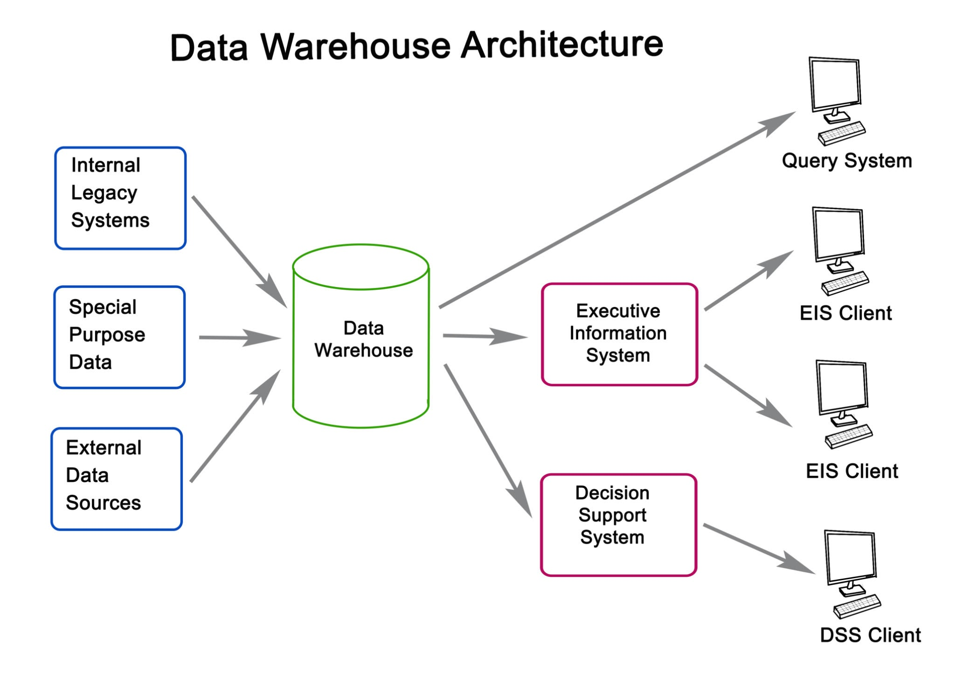
12. Development Plan and Team Roles (1–1.5 pages)
- Prototype Design – The first step is to create wireframes and user flows using Figma/Canva to define the app’s look and feel⁹³. This is the responsibility of the Designer.
- Backend Development – This involves implementing Firebase collections, authentication, and core APIs to manage user data, led by the Developer⁹⁴⁹⁴⁹⁴.
- Frontend Development – The mobile app screens and interactions are built using Flutter or React Native, utilizing the backend APIs, led by the Developer⁹⁵.
- Team Roles – The minimum team requires a Developer, a Designer, a Tester (QA), and a Business Planner (Project Manager)⁹⁶.
- Presentation – The final phase involves preparing demo screens, and highlighting the problem, target market, business model, and demo flow for potential investors or users⁹⁷.

13. Cost Estimation and Budget (1–2 pages)
The total estimated cost for a real, working prototype ranges from $900 – $1,600 USD⁹⁸. However, a self-built version leveraging free tools can be done for as low as $25 – $50 USD⁹⁹. This exercise in minimizing costs is part of Financial Feasibility Analysis and calculating Total Start-Up Cash Needed.
Category | Description | Estimated Minimum Cost (USD) | Notes / Alternatives
App Design (UI/UX) | Figma / Canva design | $100 – $200 | Can be done for free¹⁰⁰.
Frontend Development | Flutter or React Native app | $400 – $700 | Hire part-time developer or use open-source¹⁰¹.
Backend Development (Firebase) | Authentication, chat, database | $200 – $400 | Firebase has a free tier¹⁰².
AI Matching / Translation APIs | Basic AI services | $50 – $150 | Optional; can simulate initially¹⁰³.
Server / Hosting | Firebase Hosting or VPS | $0 – $50 / month | Free tier covers small projects¹⁰⁴.
Domain & Website | Basic domain for branding | $30 – $60 / year | Basic domain for branding¹⁰⁵.
Total Estimated Cost |  | $900 – $1,600 | Approx. PKR 250,000 – 450,000 ¹⁰⁶

14. Business Model and Revenue Streams (1–1.5 pages)
SkillSwap's Revenue Model is centered on premium services, maintaining the core value of free skill exchange¹⁰⁷¹⁰⁷¹⁰⁷.
- Premium Memberships – The primary stream, offering an ad-free experience, advanced matching filters, and exclusive access to expert mentors¹⁰⁸¹⁰⁸¹⁰⁸¹⁰⁸.
- Featured Mentors / Profiles – Professionals who pay a fee to rank higher in search results.
- Certification Fees – Optional paid certificates or verified badges¹⁰⁹¹⁰⁹.
- Partnerships – Collaborations with educational institutions or training centers for verified programs.
This model demonstrates Resource Sufficiency by relying on a minimal-cost service (free hosting, open-source development) to create a vast, free user base, then monetizing through value-added premium features.

15. Use Cases and User Scenarios (1–2 pages)
These scenarios demonstrate the practical value of SkillSwap, which is critical for the Business Plan to show utility.
Scenario 1: Local Skill Barter
- User A (Learner/Teacher): A university student who teaches Guitar. Needs to learn Excel for a summer internship.
- User B (Teacher/Learner): An office manager who teaches Excel. Needs to learn Guitar for a personal hobby.
- Outcome: User A exchanges 5 hours of guitar lessons for 5 hours of Excel tutorials. Both save money and gain practical skills¹¹⁰¹¹⁰¹¹⁰¹¹⁰.
Scenario 2: Global Language & Tech Exchange
- User A (Tech Skill): A programmer in Pakistan who teaches JavaScript. Needs to practice conversational Spanish.
- User B (Language Skill): A teacher in Spain who teaches Spanish. Needs basic JavaScript knowledge to manage a blog.
- Outcome: They connect using the Global Communication System. Lessons are scheduled using Global Time Synchronization and conducted using Voice & Video Translation to overcome language barriers, resulting in two distinct skills gained¹¹¹¹¹¹¹¹¹.

16. Challenges and Risk Management (1 page)
The Business Plan must address these risks:
Challenge | Management Strategy
Quality Control and Trust Issues | Handled by the Rating & Review System and Skill Verification & Badges¹¹²¹¹²¹¹²¹¹².
Scheduling Conflicts and Time Zones | Handled by Global Time Synchronization¹¹³.
Language Barriers | Handled by the Global Communication System with real-time translation tools¹¹⁴.
Technical Limits and Costs of AI APIs | Use of free/low-cost APIs initially; simulation of features until monetization allows for advanced, paid API integration¹¹⁵.

17. Expected Impact and Future Enhancements (1–1.5 pages)
SkillSwap’s expected impact aligns with the Characteristics of Successful Entrepreneurs—solving a large societal problem (cost of education):
- Democratization of Learning: Making quality learning available to students who cannot afford coaching¹¹⁶¹¹⁶¹¹⁶.
- Global Networking: Building international networks for collaboration and cultural exchange through the Global Communication System¹¹⁷.
- Future Enhancements: Future plans include AI tutors, group classes, and integration with universities or professional bodies to offer verified courses and certifications.

18. Conclusion (½–1 page)
The main problem SkillSwap addresses is the high cost and limited accessibility of quality education¹¹⁸. SkillSwap's barter-based model ¹¹⁹combined with the innovative Global Communication System ¹²⁰provides a unique and powerful solution: a self-sustaining ecosystem for learning and teaching¹²¹. This project is valuable for students, professionals, and society by promoting affordable skill growth, community, and global connectivity¹²².

19. Visual Content Suggestions
- Logo and splash screen of SkillSwap¹²³.
- User journey flowchart (Sign Up $\rightarrow$ Create Profile $\rightarrow$ Get Match $\rightarrow$ Chat / Video Call $\rightarrow$ Give Rating & Review).
- System architecture diagram (Mobile App / Web App $\rightarrow$ Firebase Backend $\rightarrow$ AI Matching Service $\rightarrow$ Translation API).
- Mockup screens: Home page, profile screen, match list, chat screen.
- World map showing global connections to highlight the Global Communication System.

Impact:
This feature turns SkillSwap into not just a skill-sharing app — but a global learning bridge that connects people through knowledge and communication. It directly addresses the global issue of language barriers in education and collaboration

SkillSwap App – Project Cost Breakdown Report
The SkillSwap App is an innovative peer-to-peer learning platform where individuals barter skills — for example, one person teaches guitar in exchange for learning Excel. The project aims to make learning accessible, affordable, and globally connected. Below is the minimum estimated cost required to develop a real, working prototype of the SkillSwap App in today’s market conditions (2025).

💰 Estimated Minimum Total Project Cost
Category | Description | Estimated Minimum Cost (USD) | Notes / Alternatives
App Design (UI/UX) | Figma / Canva design for screens, color theme, and logo. | $100 – $200 | You can do this yourself using Figma (free).
Frontend Development | Flutter or React Native app (Android + iOS) | $400 – $700 | Hire part-time developer or use open-source template.
Backend Development (Firebase) | Authentication, chat, database, file storage, notifications | $200 – $400 | Firebase has free tier; pay later if needed.
AI Matching / Translation APIs | Basic AI for matching and translation | $50 – $150 | Optional — can simulate in early version.
Server / Hosting | Firebase Hosting or VPS | $0 – $50 / month | Free tier covers small projects.
App Testing & Debugging | QA testing on Android/iOS devices | $50 – $100 | Can test yourself with Android Studio.
Logo & Branding | Professional logo set (you already have) | $0 – $50 | Already completed.
Marketing & Promotion | Social media page setup, small ad campaign | $100 – $200 | Optional; good for demo or investors.
Domain & Website | Domain (skillswapapp.com) + hosting | $30 – $60 / year | Basic domain for branding.
Miscellaneous / Contingency | Unplanned costs, API charges | $50 – $100 | Always reserve a small buffer.
💵 Total Estimated Cost: 👉 $900 – $1,600 USD (Approx. PKR 250,000 – 450,000

- except of the codding and some other skills
Total Minimum Estimated Cost
| If you use all free tools and handle development yourself |
👉 $25 – 50 (≈ Rs. 7,000 – 14,000 PKR)

